Luxembourg Data Source Support Manual

STATE STREET BANK AND TRUST COMPANY STANDARD OPERATIONAL PROCEDURE

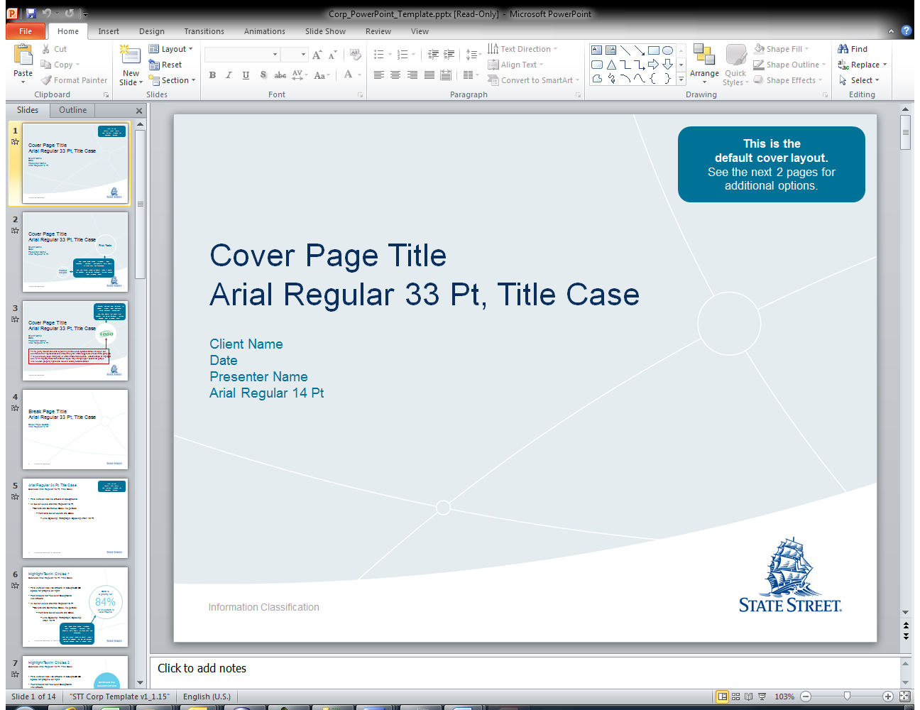

Division / Department: EMEA_Continuous_Operation_Support

Version: 1.4

Reviewed Date:

Contents

Version Log 3

1. Introduction: 4

2. ISM Ticket & Escalations 4

3. Reference 5

*Contact:* 5

*Pre-Requisites:* 5

4. Auto-sys Job Failure 5

*DLDS06_UXLDS215_O01_UND1 Jobs Failure* 5

*DLDS06_UXLDS215_O01_REF1 Jobs Failure* 6

*Bloomberg Jobs Failure* 7

5. Database Failure 7

*Database cannot be connected;* 7

*Disk Space Shortage;* 8

*Deadlock release;* 9

*Exceed Database Maximum Connection* 10

*Database Low Performance;* 12

6. System Health Check Report Failure 13

*Job Schedule Late;* 13

*Job Running Error;* 14

7. Server Failure 14

8. Others 15

# Version Log

|  |  |  |  |  |
| --- | --- | --- | --- | --- |
| **No.** | **Changes** | **Author** | **Approver** | **Review Date** |
| 1 | Initial Draft | Jin, Jiangqiang |  |  |
|  |  |  |  |  |
|  |  |  |  |  |
|  |  |  |  |  |
|  |  |  |  |  |

# Introduction:

This document is to give guidance when system level issue occurred during supporting LDS. This document is maintained within EMEA CONTINOUS OPERATIONS team.

# ISM Ticket & Escalations

*Base on urgency and importance, the ISM ticket can be categorized differently, from a resilience support perspective, below are the most commonly used types of requests, as well as the manual of Command Center call.*

|  |  |  |  |  |
| --- | --- | --- | --- | --- |
| **Criteria & ETA** | **Action** | **Priority** | **Affect** | **Description** |
| Not very urgent, No close Deadline | Service Request | 3 | Low | For instance, account unlock |
| Over 2 hours buffer time | Incident Ticket | 3 | Medium | The issue happens at 3PM, and the fix time is required on 6PM |
| Within 1-2 hours buffer time | Incident Ticket | 2 | High | The issue happens at 3PM, and the fix time is required on 4:30PM |
| Within 1 hour buffer time | Incident Ticket | 1 | High | The issue happens at 4PM, and require fixing at 5PM with SLA/Client deliverables, this also require command center call to get all the concerned team aware and start to fix, phone number: xxxxxx  This type of incident would require a further root cause analysis from Lux AD team. |
| When MI is opened | Command Center Call | NA | NA | When issue happens, if it is identified by ECO team, ECO team will open a command center call and ask them to involve GSS team; if it is identified by GSS team(reported by user), GSS team will open command center call and involve our team; |

*Instruction to open a ticket:*

Login ISM: <https://ism.statestr.com/>

Go to My ticket or my group ticket to draft a new ticket on requirement and assign it to corresponding team.

*-*

*Command Center Call Process*

Firstly Email CommandCenter CommandCenter@statestreet.com, and then call 617-985-9204

Template as below:

|  |
| --- |
| Hi CommandCenter:  Could you help us to open a command center call for a production issue by *****? Please include the ***** team into the call.  The ticket number is IN******. |

# Reference

## Contact:

|  |  |
| --- | --- |
| **Name** | **Contact Information** |
| SQL DB | Email: sscoradb@in.ibm.com  ISM Group: IBM-DM-ORACLE |
| Server Team | ISM Group: IBM-SMD-UNIX |
| Application Owner | Name: Conzelmann, Franck [fconzelmann@statestreet.com](mailto:fconzelmann@statestreet.com)  Phone: +352 464 0 10 621 |
| Business Manager | Name: Fagnart, Fabrice [ffagnart@statestreet.com](mailto:ffagnart@statestreet.com)  Phone: +352 464 0 10 207 |
| Lux IA support(L1 Support/GSS) | Email: [LuxembourgIASupport@statestreet.com](mailto:LuxembourgIASupport@statestreet.com)  ISM Group: SSC-GSS-EMEA-LUX |
| OSA Support | Email: OSR-Support@StateStreet.com |

## Pre-Requisites:

LAN ID should be active;

PROD Interchange id should be active;

LDS Database access should be active;

Folders access should be active;

# Auto-sys Job Failure

## DLDS06_UXLDS215_O01_UND1 Jobs Failure

**Issue Description:**

auto-sys job dlds06_uxlds215_o01_und1 has failed

**Reference:**

Dlds06_uxlds215_o01_und1 is used to solve fund locked issue.

|  |  |
| --- | --- |
| Job Name | Log Path |
| dlds06_uxlds215_o01_und1 | /dlds06/lds/oracle/log/LDSundertaker.log |

**Fix:**

1. Connect to O04LDS3 instance and Run below query to get the error.

|  |
| --- |
| Select * from LUXPROJECT.LOG_SCHEDULE where STATUS ='ERROR' order by TIMESTAMPE DESC;  --Long process can be retrieved also with below view:  Select * from luxproject.VREAD_CONTROL_LONGPROCESS  --check the status of the fund, if it’s ‘S’, it means system fix the error automatic.  SELECT * FROM LUXPROJECT.PR_INTERNAL_LIST where fund=$FUND'; |

1. Log on server DLDS06 and get the log from the log path. Then analyze.
2. If dlds06_uxlds215_o01_pro1 is failed and its reason is locked fund(refer to Page 10, Deadlock release), then wait dlds06_uxlds215_o01_und1 running to kill the locked session.
3. If dlds06_uxlds215_o01_und1 is failed, it means there is error in killing the locked session, analyze the reason.
4. If other situation, analyze and try to solve it.

## DLDS06_UXLDS215_O01_REF1 Jobs Failure

**Issue Description:**

auto-sys job dlds06_uxlds215_o01_ref1 has failed

**Reference:**

Dlds06_uxlds215_o01_ref1 is used to refresh LDS database views.

|  |  |
| --- | --- |
| Job Name | Log Path |
| dlds06_uxlds215_o01_ref1 | /dlds06/lds/oracle/log/LDSDEAMMatViewsint.log; /dlds06/lds/oracle/log/LDSDEAMMatViews.log |

**Fix:**

1. Connect to O04LDS3 instance and Run below query to get the error.

|  |
| --- |
| Select * from LUXPROJECT.LOG_SCHEDULE where STATUS ='ERROR' order by TIMESTAMPE DESC; |

1. Check the Event in the result of setp1 to determine it belong to FFCLOADER or Scheduler, then run

|  |
| --- |
| SELECT * FROM LUXPROJECT.PR_INTERNAL_LIST where fund=$FUND'; --it's for FFCLOADER , $FUND can be found from EVENT field, if the status is ‘S’, it means system fix the error automatic.  SELECT * FROM LUXPROJECT.PR_SCHEDULES WHERE CODE='$CODE'; -- it's for Scheduler, if the status is 0, it means system fix the error automatic. |

1. If it’s not fixed automatic, then Log on server DLDS06 and get the log from the log path. Then analyze.

## Bloomberg Jobs Failure

**Issue Description:**

auto-sys job lu1pw3270_uxlds215_bbgget, lu1pw3270_uxlds215_bbgload or lu1pw3270_uxlds215_bbgput has failed

**Reference:**

lu1pw3270_uxlds215_bbgget is used to get Bloomberg files. lu1pw3270_uxlds215_bbgload is used to load Bloomberg file to LDS database. lu1pw3270_uxlds215_bbgput is used to retrieve data from LDS database to Bloomberg server.

|  |  |
| --- | --- |
| Job Name | Log Path |
| lu1pw3270_uxlds215_bbgget | / \\lu1pw3270\vendor_apps\Autosyslogs\lu1pw3270_uxlds215_bbgget_out.log |
| lu1pw3270_uxlds215_bbgload | \\lu1pw3270\vendor_apps\Autosyslogs\lu1pw3270_uxlds215_bbgload_out.log |
| lu1pw3270_uxlds215_bbgput | \\lu1pw3270\vendor_apps\Autosyslogs\lu1pw3270_uxlds215_bbgput_out.log |

**Fix:**

1. Get the log to analysis.

# Database Failure

## Database cannot be connected;

**Issue description:**

PROD Database (DLDS06) is reported as cannot be connected

**Fix:**

1. Tyr to connect to DLDS06 by Oracle SQL developer tool, like Oracle SQL Developer.
2. If return with message: invalid username/password, please check and correct.
3. If receive other messages and can’t connect to the server, then a command center call is required; please refer to 2.ISM Ticket & GSS Escalations in page 4;

Open an ISM ticket to describe the issue and assign it to IBM-DM-DATABASE.

Login ISM with LAN Login

Go to Tab: MY GROUP TICKETS – New Service Request

Below is the ticket template:

|  |
| --- |
| **Summary**: LDS DB Connection Failure  **Detail:**  Hi Team,    The below database is not able to be connected, please urgently check and revert.  Server Name: DLDS06  Regards, |

If the database team is experiencing difficulty on fixing this issue and in doubt of other causes, please inform Lux AD team;

## Disk Space Shortage;

**Issue Description:**

When receiving an alert giving a notice that

1. The database space is over 85% usages;
2. The database is already not able to be connected due to space shortage;
3. The database has a high increase speed on space use;

The database space shortage contains but not limit to the above situation, when it is observed that the database space usage is not functioning as usual, a fix should be launched

**Fix:**

Open an ISM ticket to describe the issue and assign it to IBM-DM-DATABASE.

Input below query in database:

|  |
| --- |
| select  fs.tablespace_name "Tablespace",  (df.totalspace - fs.freespace) "Used MB",  fs.freespace "Free MB",  df.totalspace "Total MB",  round(100 * (fs.freespace / df.totalspace)) "Pct. Free"  from  (select  tablespace_name,  round(sum(bytes) / 1048576) TotalSpace  from  dba_data_files  group by  tablespace_name  ) df,  (select  tablespace_name,  round(sum(bytes) / 1048576) FreeSpace  from  dba_free_space  group by  tablespace_name  ) fs  where  df.tablespace_name = fs.tablespace_name; |

Login ISM with LAN Login

Go to Tab: MY GROUP TICKETS – New Service Request

Below is the ticket template:

|  |
| --- |
| **Summary**: LDS DB Connection Failure  **Detail**:  Hi Team,    The below database is with low spaces, please urgently check and revert.  Server Name: DLDS06  Table Space:  <add query return value>  Regards, |

If the database team is experiencing difficulty on fixing this issue and in doubt of other causes, please inform Lux AD team;

## Deadlock release;

**Issue Description:**

Database is experiencing deadlock.

**Fix:**

1. Run below query in the database;

|  |
| --- |
| SELECT * FROM  (SELECT b.inst_id,  b.session_id AS sid,  c.SERIAL# AS PROCESS,  NVL(b.oracle_username, '(oracle)') AS username,  a.owner AS object_owner,  a.object_name,  Decode(b.locked_mode, 0, 'None',  1, 'Null (NULL)',  2, 'Row-S (SS)',  3, 'Row-X (SX)',  4, 'Share (S)',  5, 'S/Row-X (SSX)',  6, 'Exclusive (X)',  b.locked_mode) locked_mode,  b.os_user_name  FROM dba_objects a,  gv$locked_object b,  gv$session c  WHERE a.object_id = b.object_id  AND c.SID = b.session_id  ORDER BY 1, 2, 3, 4) WHERE USERNAME = ‘LUXPROJECT’; |

If there are values returned, it means deadlock is there. Run the below query to check if the deadlock is because of locked fund. Please replace “xxxx” with the PROCESS field you search in prior step.

|  |
| --- |
| Select * from LUXPROJECT.LOG_SCHEDULE where status like 'Locked%' AND PROCESS in (xxxx,xxxx) order by TIMESTAMPE DESC; |

1. If there are values returned, wait autosys job dlds06_uxlds215_o01_und1 running to kill the locked session.
2. If there are no values returned, it means it’s for other reasons,then an ISM ticket needs to be raised immediately to release the process that deadlock occurs.

Open an ISM ticket to describe the issue and assign it to IBM-DM-DATABASE.

Login ISM with LAN Login

Go to Tab: MY GROUP TICKETS – New Service Request

Below is the ticket template:

|  |
| --- |
| **Summary**: LDS DB Deadlock Require release  **Detail**:  Hi Team,    The below query in the database is with deadlock, please urgently check and release the deadlock process.  Server Name: DLDS06  Query: < Put the deadlock query here >  Result: <Put the deadlock query result here>    Regards, |

## Exceed Database Maximum Connection

**Issue Description:**

[Maximum number of sessions exceed](https://community.oracle.com/message/10711574#10711574), connection failed

**Fix:**

1. If can connect to DLDS06 ,
2. Run below query to check if currently sessions are more than system allowed max value.

|  |
| --- |
| Select value from v$parameter where name = 'sessions';  Select count(*) from v$session;  --view the session detals  SELECT SID  || ','  || SERIAL# AS SESSIONID,  USERNAME  || '('  || OSUSER  || ')' AS USERNAME,  INST_ID,  MODULE,  SQL_ID,  STATUS,  LOGON_TIME-5/24 AS LOGONTIME,  sys_context('USERENV','DB_NAME') AS DATABASE  FROM GV$SESSION  WHERE MODULE <> 'SQL Developer'  AND MODULE <> 'SQL*Plus'  AND STATUS <> 'KILLED'; |

If yes, go to step 3 to analyze.

1. Most of time you can’t connect to DLDS06 in this situation, then try to run the below query in Monitor DB – O01PVT1 to get the historical session information, and go to step 3

|  |
| --- |
| SELECT * FROM MIPMON.CORE_JOB_MONITOR_LOG_DATA  WHERE monitor_id =(SELECT MAX(monitor_id)  FROM MIPMON.CORE_JOB_MONITOR_LOG  WHERE job_cd='LDS_DATABASE_SESSION_COLLECTOR_1'); |

1. Analyze the session information:
2. Check sessions’ user & module names, if most of sessions are initiated by individual connection, then open an ISM ticket to describe the issues and assign to IBM-DM-DATABASE.
3. If most of sessions are initiated by LDS application process, then analyze furthur. At the same time, open an ISM ticket to describe the issues.

ISM ticket open steps:

Login ISM with LAN Login

Go to Tab: MY GROUP TICKETS – New Service Request

Below is the ticket template:

|  |
| --- |
| **Summary**: Exceed Maximum Connection ID in LDS Database  **Detail**:  Hi Team,    The below database has exceeded the maximum connection, please urgently check and fix.  Server Name: DLDS06  Query: <Put the SQL query here>  Result: <Put the SQL query result here>  <Your analysis>  Regards, |

If the database team is experiencing difficulty on fixing this issue and in doubt of other causes, please inform Lux AD team;

## Database Low Performance;

**Issue Description:**

Database is reported as running or operating slowly;

When receiving an alert giving a notice that:

1. The database memory is over 85% usages;
2. The database is already running slowly due to space shortage;
3. The database has a high increase speed on memory usage;

The database memory shortage contains but not limit to the above situation, when it is observed that the database memory usage is higher than usual, a fix should be launched.

**Fix:**

1. Check if the SQL Server is using all available memory, run below query in the database;

|  |
| --- |
| select sum(value)/(1024*1024) as total_memory from v$sga;  select name, value/(1024*1024) as useage_memory from v$pgastat where name like 'total PGA a%'; |

If the SQL Server database is using high memory, open an ISM ticket to describe the issue and assign it to IBM-DM-DATABASE.

Login ISM with LAN Login

Go to Tab: MY GROUP TICKETS – New Service Request

Below is the ticket template:

|  |
| --- |
| **Summary**: LDS Database running slow  **Detail**:  Hi Team,    The below database is operating very slowly, please urgently check and fix, please be informed that we have a SLA behind in xx minutes.  Server Name: DLDS06  Query: <Put the SQL query here>  Result: <Put the SQL query result here>  Regards, |

1. If the reason that caused the slowness is the query running within LDS database, raise up another ticket to IBM-DM-DATABASE for performance report and analyze further to see if this persists for period of time, if so, further check is required with Lux AD team on permanent fix resolution.

# System Health Check Report Failure

**Issue Description:**

System Health Check Report cannot be generated automatically.

**Fix:**

Generate report manually by running query on desktop.

## Job Schedule Late;

**Issue Description:**

If there is job not finished in time, one alert email like below will be send. This is a new method to monitor job status, replacing with Autosys job - DLDS06_UXLDS215_O01_SCH1 .

|  |
| --- |
| **Summary**: [WARNING] LDS Late Schedule Job  **Detail**:  Schedule ['GT03'] jobs are late in LDS DB - O04LDS3, please check in O04LDS3.  You can run the below query to check the status: if the last run date is not today or the status is 10, there is errors.  SELECT * FROM LUXPROJECT.PR_SCHEDULES WHERE code in ('GT03'); |

**Fix:**

1. Connect to O04LDS3 instance and check LUXPROJECT.PR_SCHEDULES table to sees if one status is different to 0. If there are values returned, go to next step.

Select * from LUXPROJECT.PR_SCHEDULES WHERE STATUS !=0;

1. Run below query to get the error.

Select * from LUXPROJECT.LOG_SCHEDULE where STATUS ='ERROR' order by TIMESTAMPE DESC;

## Job Running Error;

**Issue Description:**

If there is error in job running, one alert email like below will be send. This is a new method to monitor job status, replacing with Autosys job - DLDS06_UXLDS215_O01_ERR1 .

|  |
| --- |
| **Summary**: [ERROR] LDS Process Has Error Log  **Detail**:  Please be aware that the process events [GT03] have error logs at 20170414 09:03:25 (CET time),  The error message are  [ORA-20104: Validation rule Failed! (expected 1 rows and received only 0)  ORA-06512: at "LUXPROJECT.SPPR0_VALIDATE_SCHEDULE", line 76  ORA-06512: at line 1  Validation failure for GT03 XRates from OSR into wk_XRates]  You can run the below SQL in DB O04LDS3 to find the details  SELECT * FROM LUXPROJECT.LOG_SCHEDULE  WHERE PROCESS= '16365'  ORDER BY TIMESTAMPE DESC, step DESC; |

**Fix:**

You can find the detail in the email, then check with corresponding team.

# Server Failure

**Issue Description:**

Server cannot be connected.

**Reference:**

|  |  |
| --- | --- |
| **Server Type** | **Server Name** |
| Unix Server | DLDS06 |

**Fix:**

Check if server DLDS06 can be connected, if still can’t connect the server. A command center call is required; please refer to 2.ISM Ticket & GSS Notification Escalations in page 4.

1. Open an ISM ticket to describe the issue and assign it to IBM-SMD-UNIX .

Login ISM with LAN ID, then go to Tab: MY GROUP TICKETS – New Service Request

Below is the ticket template:

|  |
| --- |
| Summary: Server Connection Failure  Detail:    Hi Team,    The server is unable to be connected, please urgently check and revert.  Server Name: DLDS06  System: UNIX server  Regards |

If the Server team is experiencing difficulty on fixing this issue and in doubt of other causes, please inform Lux AD team.

# Others

**Issue Description:**

Any SR ticket to request to get ETR extract in csv format for funds;

**Fix:**

1. Using CMD navigate to the following path:

“\\LUXPWDAT03\newdata\DEPTS\Systems\IPS\PM\Projects\EuropeanTaxReporting-PIR-362\LDS Queries”

1. Using the makemaster.bat file you can create the etr_master.sql to be executed in SQL-Plus
2. \\LUXPWDAT03\newdata\DEPTS\Systems\IPS\PM\Projects\EuropeanTaxReporting-PIR-362\LDS Queries>makemaster.bat ETRFunds.csv
3. Connecting sqlPlus to LDS, and executing etr_master.sql will spool data for one fund per file into the same directory.
4. Copy the target file to user.